Intelligence (Part 1):
- Definition
Intelligence has been an important and controversial topic throughout psychology's history. Despite the substantial interest in the subject, there is still considerable disagreement about what components make up intelligence. In addition to questions of exactly how to define intelligence, the debate continues today about whether accurate measurements are even possible.
At various points throughout recent history, researchers have proposed some different definitions of intelligence. While these definitions can vary considerably from one theorist to the next, current conceptualizations tend to suggest that intelligence involves the level of ability to do the following:
- Learn: The acquisition, retention, and use of knowledge is an important component of intelligence.
- Recognize problems: To put knowledge to use, people must be able to identify possible problems in the environment that need to be addressed.
- Solve problems: People must then be able to take what they have learned to come up with a useful solution to a problem they have noticed in the world around them.¹﻿
Intelligence involves some different mental abilities including logic, reasoning, problem-solving, and planning. While the subject of intelligence is one of the largest and most heavily researched, it is also one of the topics that generate the greatest controversy.
Research on intelligence plays a significant role in many areas. These areas include decisions regarding how much funding should be given to educational programs, the use of testing to screen job applicants, and the use of testing to identify children who need additional academic help.
An exceptional related case is the savant syndrome that is observed in some individuals diagnosed with autism or mental retardation. They are characterized by exceptional talent in one area of functioning, such as music or math, and poor mental functioning in all other areas.

Theories of Intelligence
Different researchers have proposed a variety of theories to explain the nature of intelligence. Here are some of the major theories of intelligence that have emerged during the last 100 years:

Charles Spearman: General Intelligence
British psychologist Charles Spearman (1863–1945) described a concept he referred to as general intelligence or the g factor. After using a technique known as factor analysis to examine some mental aptitude tests, Spearman concluded that scores on these tests were remarkably similar. People who performed well on one cognitive test tended to perform well on other tests, while those who scored badly on one test tended to score badly on others. He concluded that intelligence is a general cognitive ability that can be measured and numerically expressed.

Louis L. Thurstone: Primary Mental Abilities
Psychologist Louis L.Thurstone (1887–1955) offered a differing theory of intelligence. Instead of viewing intelligence as a single, general ability, Thurstone's theory focused on seven different primary mental abilities. The abilities that he described include:
- Verbal comprehension
- Reasoning
- Perceptual speed
- Numerical ability
- Word fluency
- Associative memory
- Spatial visualization⁴﻿

Howard Gardner: Multiple Intelligences
One of the more recent ideas to emerge is Howard Gardner's theory of multiple intelligences. Instead of focusing on the analysis of test scores, Gardner proposed that numerical expressions of human intelligence, such as in the IQ test, are not a full and accurate depiction of people's abilities. His theory describes eight distinct types of intelligence based on skills and abilities that are valued in different cultures.⁵﻿
The eight kinds of intelligence Gardner described are:
- Visual-spatial intelligence
- Verbal-linguistic intelligence
- Bodily-kinesthetic intelligence
- Logical-mathematical intelligence
- Interpersonal intelligence
- Musical intelligence
- Intrapersonal intelligence
- Naturalistic intelligence

Robert Sternberg: Triarchic Theory of Intelligence
Psychologist Robert Sternberg defined intelligence as "mental activity directed toward purposive adaptation to, selection, and shaping of real-world environments relevant to one's life." While he agreed with Gardner that intelligence is much broader than a single, general ability, he instead suggested that some of Gardner's types of intelligence are better viewed as individual talents. Sternberg proposed what he referred to as "successful intelligence," which involves three different factors:
- Analytical intelligence: Your problem-solving abilities.
- Creative intelligence: Your capacity to deal with new situations using past experiences and current skills.
- Practical intelligence: Your ability to adapt to a changing environment.

Measuring Intelligence: Standardization and the Intelligence Quotient
The goal of most intelligence tests is to measure g, the general intelligence factor. Good intelligence tests are reliable, meaning that they are consistent over time, and also demonstrate construct validity, meaning that they actually measure intelligence rather than something else. Because intelligence is such an important individual difference dimension, psychologists have invested substantial effort in creating and improving measures of intelligence, and these tests are now the most accurate of all psychological tests. In fact, the ability to accurately assess intelligence is one of the most important contributions of psychology to everyday public life.
Intelligence changes with age. A three-year-old who could accurately multiply 183 by 39 would certainly be intelligent, but a 25-year-old who could not do so would be seen as unintelligent. Thus understanding intelligence requires that we know the norms or standards in a given population of people at a given age. The standardization of a test involves giving it to a large number of people at different ages and computing the average score on the test at each age level.
It is important that intelligence tests be standardized on a regular basis because the overall level of intelligence in a population may change over time. The Flynn effect refers to the observation that scores on intelligence tests worldwide have increased substantially over the past decades (Flynn, 1999). Although the increase varies somewhat from country to country, the average increase is about three intelligence (IQ) points every 10 years. There are many explanations for the Flynn effect, including better nutrition, increased access to information, and more familiarity with multiple-choice tests (Neisser, 1998). But whether people are actually getting smarter is debatable (Neisser, 1997).
Once the standardization has been accomplished, we have a picture of the average abilities of people at different ages and can calculate a person’s mental age, which is the age at which a person is performing intellectually. If we compare the mental age of a person to the person’s chronological age, the result is the IQ, a measure of intelligence that is adjusted for age. A simple way to calculate IQ is by using the following formula:
IQ = mental age ÷ chronological age × 100.
Thus a 10-year-old child who does as well as the average 10-year-old child has an IQ of 100 (10 ÷ 10 × 100), whereas an eight-year-old child who does as well as the average 10-year-old child would have an IQ of 125 (10 ÷ 8 × 100). Most modern intelligence tests are based the relative position of a person’s score among people of the same age, rather than on the basis of this formula, but the idea of an intelligence ratio or quotient provides a good description of the score’s meaning.
A number of scales are based on the IQ. The Wechsler Adult lntelligence Scale (WAIS) is the most widely used intelligence test for adults (Watkins, Campbell, Nieberding, & Hallmark, 1995). The current version of the WAIS, the WAIS-IV, was standardized on 2,200 people ranging from 16 to 90 years of age. It consists of 15 different tasks, each designed to assess intelligence, including working memory, arithmetic ability, spatial ability, and general knowledge about the world (see Figure 1, “Sample Items from the Wechsler Adult Intelligence Scale (WAIS)”). The WAIS-IV yields scores on four domains: verbal, perceptual, working memory, and processing speed. The reliability of the test is high (more than 0.95), and it shows substantial construct validity. The WAIS-IV is correlated highly with other IQ tests such as the Stanford-Binet, as well as with criteria of academic and life success, including grades, measures of work performance, and occupational level. It also shows significant correlations with measures of everyday functioning among the mentally retarded.
The Wechsler scale has also been adapted for preschool children in the form of the Wechsler Primary and Preschool Scale of Intelligence (WPPSI-III) and for older children and adolescents in the form of the Wechsler Intelligence Scale for Children (WISC-IV).
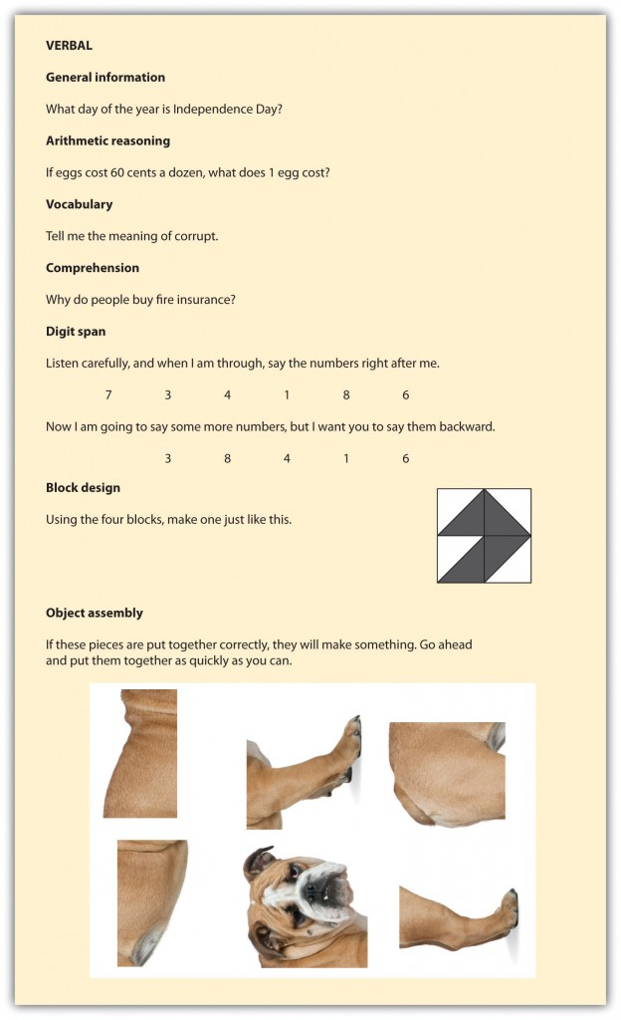
Figure 1 Sample Items from the Wechsler Adult Intelligence Scale (WAIS).
Refrences
SparkNotes Editors. (2005). SparkNote on Intelligence. Retrieved March 23, 2020, from http://www.sparknotes.com/psychology/psych101/intelligence/
https://www.verywellmind.com/theories-of-intelligence-2795035
https://opentextbc.ca/introductiontopsychology/chapter/9-1-defining-and-measuring-intelligence/

