PART 2:

The Influence of Heredity and Environment
Today, researchers generally agree that heredity and environment have an interactive influence on intelligence. Many researchers believe that there is a Reaction Range to IQ, which refers to the limits placed on IQ by heredity. Heredity places an upper and lower limit on the IQ that can be attained by a given person. The environment determines where within these limits the person’s IQ will lie.
Despite the prevailing view that both heredity and environment influence intelligence, researchers still have different opinions about how much each contributes and how they interact.
Evidence for hereditary influences on intelligence comes from the following observations:
- Family studies show that intelligence tends to run in families.
- Twin studies show a higher correlation between identical twins in IQ than between fraternal twins. This holds true even when identical twins reared apart are compared to fraternal twins reared together.
- Adoption studies show that adopted children somewhat resemble their biological parents in intelligence.
Family studies, twin studies, and adoption studies, however, are not without problems. Heritability is a mathematical estimate that indicates how much of a trait’s variation in a population can be attributed to genes. Estimates of the heritability of intelligence vary, depending on the methods used. Most researchers believe that heritability of intelligence is between 60 percent and 80 percent.
So far, heritability estimates have been based mostly on studies using white, middle-class subjects. Even if heritability of IQ is high, heredity does not necessarily account for differences between groups.

Environmental Influences
Evidence for environmental influences on intelligence comes from the following observations:
- Adoption studies demonstrate that adopted children show some similarity in IQ to their adoptive parents.
- Adoption studies also show that siblings reared together are more similar in IQ than siblings reared apart. This is true even when identical twins reared together are compared to identical twins reared apart.
- Biologically unrelated children raised together in the same home have some similarity in IQ.
- IQ declines over time in children raised in deprived environments, such as understaffed orphanages or circumstances of poverty and isolation. Conversely, IQ improves in children who leave deprived environments and enter enriched environments.
- People’s performance on IQ tests has improved over time in industrialized countries. This strange phenomenon, which is known as the Flynn Effect, is attributed to environmental influences. It cannot be due to heredity, because the world’s gene pool could not have changed in the seventy years or so since IQ testing began.
  - Possible Causes of The Flynn Effect
The precise cause for the Flynn effect is unclear. Researchers speculate that it may be due to environmental factors such as decreased prevalence of severe malnutrition among children, enhancing of skills through television and video games, improved schools, smaller family sizes, higher level of parental education, or improvements in parenting.

Is Intelligence Nature or Nurture?
Intelligence has both genetic and environmental causes, and these have been systematically studied through a large number of twin and adoption studies (Neisser et al., 1996; Plomin, 2003). These studies have found that between 40% and 80% of the variability in IQ is due to genetics, meaning that overall, genetics plays a bigger role than environment does in creating IQ differences among individuals (Plomin & Spinath, 2004). The IQs of identical twins correlate very highly (r = .86), much higher than do the scores of fraternal twins who are less genetically similar (r = .60). And the correlations between the IQs of parents and their biological children (r = .42) is significantly greater than the correlation between parents and adopted children (r = .19). The role of genetics gets stronger as children get older. The intelligence of very young children (less than 3 years old) does not predict adult intelligence, but by age 7 it does, and IQ scores remain very stable in adulthood (Deary, Whiteman, Starr, Whalley, & Fox, 2004).
But there is also evidence for the role of nurture, indicating that individuals are not born with fixed, unchangeable levels of intelligence. Twins raised together in the same home have more similar IQs than do twins who are raised in different homes, and fraternal twins have more similar IQs than do nontwin siblings, which is likely due to the fact that they are treated more similarly than nontwin siblings are.
The fact that intelligence becomes more stable as we get older provides evidence that early environmental experiences matter more than later ones. Environmental factors also explain a greater proportion of the variance in intelligence for children from lower-class households than they do for children from upper-class households (Turkheimer, Haley, Waldron, D’Onofrio, & Gottesman, 2003). This is because most upper-class households tend to provide a safe, nutritious, and supporting environment for children, whereas these factors are more variable in lower-class households.
Social and economic deprivation can adversely affect IQ. Children from households in poverty have lower IQs than do children from households with more resources even when other factors such as education, race, and parenting are controlled (Brooks-Gunn & Duncan, 1997). Poverty may lead to diets that are undernourishing or lacking in appropriate vitamins, and poor children may also be more likely to be exposed to toxins such as lead in drinking water, dust, or paint chips (Bellinger & Needleman, 2003). Both of these factors can slow brain development and reduce intelligence.
If impoverished environments can harm intelligence, we might wonder whether enriched environments can improve it. Government-funded after-school programs such as Head Start are designed to help children learn. Research has found that attending such programs may increase intelligence for a short time, but these increases rarely last after the programs end (McLoyd, 1998; Perkins & Grotzer, 1997). But other studies suggest that Head Start and similar programs may improve emotional intelligence and reduce the likelihood that children will drop out of school or be held back a grade (Reynolds, Temple, Robertson, & Mann 2001).
Intelligence is improved by education; the number of years a person has spent in school correlates at about r = .6 with IQ (Ceci, 1991). In part this correlation may be due to the fact that people with higher IQ scores enjoy taking classes more than people with low IQ scores, and thus they are more likely to stay in school. But education also has a causal effect on IQ. Comparisons between children who are almost exactly the same age but who just do or just do not make a deadline for entering school in a given school year show that those who enter school a year earlier have higher IQ than those who have to wait until the next year to begin school (Baltes & Reinert, 1969; Ceci & Williams, 1997). Children’s IQs tend to drop significantly during summer vacations (Huttenlocher, Levine, & Vevea, 1998), a finding that suggests that a longer school year, as is used in Europe and East Asia, is beneficial.
It is important to remember that the relative roles of nature and nurture can never be completely separated. A child who has higher than average intelligence will be treated differently than a child who has lower than average intelligence, and these differences in behaviours will likely amplify initial differences. This means that modest genetic differences can be multiplied into big differences over time.

The Biology of Intelligence
The brain processes underlying intelligence are not completely understood, but current research has focused on four potential factors: brain size, sensory ability, speed and efficiency of neural transmission, and working memory capacity.
There is at least some truth to the idea that smarter people have bigger brains. Studies that have measured brain volume using neuroimaging techniques find that larger brain size is correlated with intelligence (McDaniel, 2005), and intelligence has also been found to be correlated with the number of neurons in the brain and with the thickness of the cortex (Haier, 2004; Shaw et al., 2006). It is important to remember that these correlational findings do not mean that having more brain volume causes higher intelligence. It is possible that growing up in a stimulating environment that rewards thinking and learning may lead to greater brain growth (Garlick, 2003), and it is also possible that a third variable, such as better nutrition, causes both brain volume and intelligence.
Another possibility is that the brains of more intelligent people operate faster or more efficiently than the brains of the less intelligent. Some evidence supporting this idea comes from data showing that people who are more intelligent frequently show less brain activity (suggesting that they need to use less capacity) than those with lower intelligence when they work on a task (Haier, Siegel, Tang, & Abel, 1992). And the brains of more intelligent people also seem to run faster than the brains of the less intelligent. Research has found that the speed with which people can perform simple tasks — such as determining which of two lines is longer or pressing, as quickly as possible, one of eight buttons that is lighted — is predictive of intelligence (Deary, Der, & Ford, 2001). Intelligence scores also correlate with measures of working memory (Ackerman, Beier, & Boyle, 2005), and working memory is now used as a measure of intelligence on many tests.
Although intelligence is not located in a specific part of the brain, it is more prevalent in some brain areas than others. Duncan et al. (2000) administered a variety of intelligence tasks and observed the places in the cortex that were most active. Although different tests created different patterns of activation, as you can see in Figure 10.52, “Where Is Intelligence?”, these activated areas were primarily in the outer parts of the cortex, the area of the brain most involved in planning, executive control, and short-term memory.
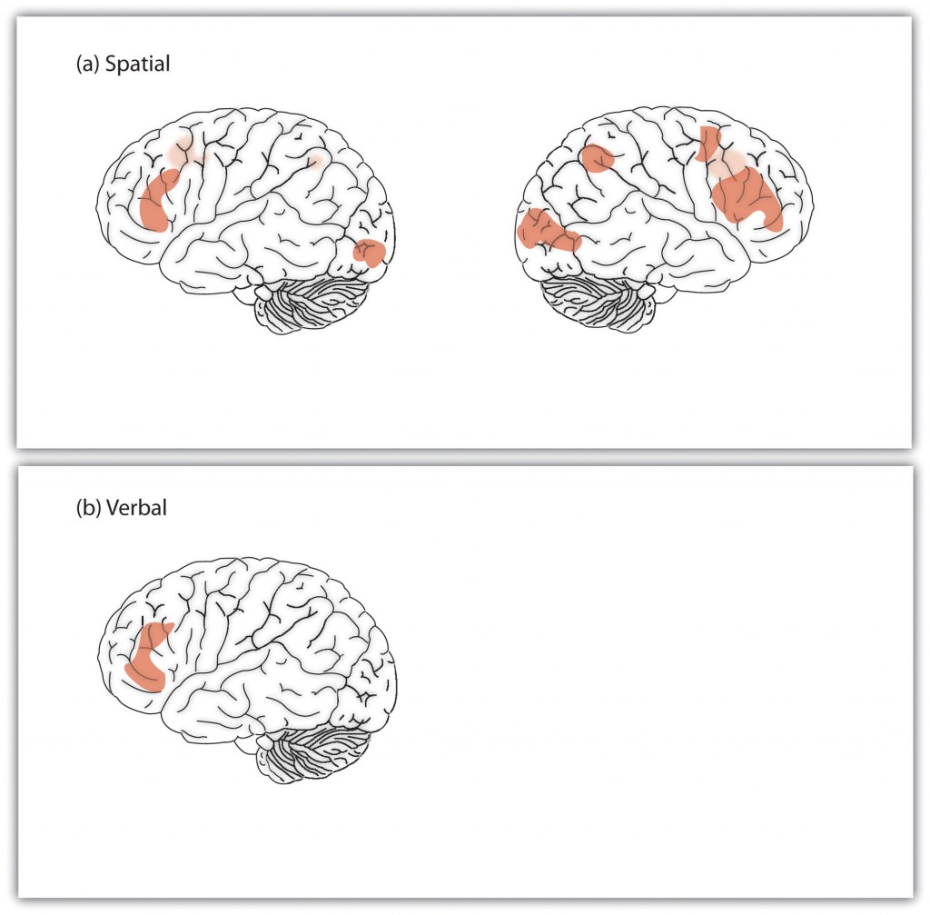
Figure 2, Where Is Intelligence? fMRI studies have found that the areas of the brain most related to intelligence are in the outer parts of the cortex.
  - Emotional Intelligence
Although most psychologists have considered intelligence a cognitive ability, people also use their emotions to help them solve problems and relate effectively to others. Emotional intelligence refers to the ability to accurately identify, assess, and understand emotions, as well as to effectively control one’s own emotions (Feldman-Barrett & Salovey, 2002; Mayer, Salovey, & Caruso, 2000).
The idea of emotional intelligence is seen in Howard Gardner’s interpersonal intelligence (the capacity to understand the emotions, intentions, motivations, and desires of other people) and intrapersonal intelligence (the capacity to understand oneself, including one’s emotions). Public interest in, and research on, emotional intellgence became widely prevalent following the publication of Daniel Goleman’s best-selling book, Working with emotional intelligence (1998).
There are a variety of measures of emotional intelligence (Mayer, Salovey, & Caruso, 2008; Petrides & Furnham, 2000). One popular measure, the Mayer-Salovey-Caruso Emotional Intelligence Test (http://www.emotionaliq.org), includes items about the ability to understand, experience, and manage emotions, such as these:
- What mood(s) might be helpful to feel when meeting in-laws for the very first time?
- Tom felt anxious and became a bit stressed when he thought about all the work he needed to do. When his supervisor brought him an additional project, he felt ____ (fill in the blank).
- Contempt most closely combines which two emotions?
  - anger and fear
  - fear and surprise
  - disgust and anger
  - surprise and disgust
- Debbie just came back from vacation. She was feeling peaceful and content. How well would each of the following actions help her preserve her good mood?
  - Action 1: She started to make a list of things at home that she needed to do.
  - Action 2: She began thinking about where and when she would go on her next vacation.
  - Action 3: She decided it was best to ignore the feeling since it wouldn’t last anyway.
One problem with emotional intelligence tests is that they often do not show a great deal of reliability or construct validity (Føllesdal & Hagtvet, 2009). Although it has been found that people with higher emotional intelligence are also healthier (Martins, Ramalho, & Morin, 2010), findings are mixed about whether emotional intelligence predicts life success — for instance, job performance (Harms & Credé, 2010). Furthermore, other researchers have questioned the construct validity of the measures, arguing that emotional intelligence really measures knowledge about what emotions are, but not necessarily how to use those emotions (Brody, 2004), and that emotional intelligence is actually a personality trait, a part of g, or a skill that can be applied in some specific work situations — for instance, academic and work situations (Landy, 2005).
Although measures of the ability to understand, experience, and manage emotions may not predict effective behaviours, another important aspect of emotional intelligence — emotion regulation — does. Emotion regulation refers to the ability to control and productively use one’s emotions. Research has found that people who are better able to override their impulses to seek immediate gratification and who are less impulsive also have higher cognitive and social intelligence. They have better test scores, are rated by their friends as more socially adept, and cope with frustration and stress better than those with less skill at emotion regulation (Ayduk et al., 2000; Eigsti et al., 2006; Mischel & Ayduk, 2004).
Because emotional intelligence seems so important, many school systems have designed programs to teach it to their students. However, the effectiveness of these programs has not been rigorously tested, and we do not yet know whether emotional intelligence can be taught, or if learning it would improve the quality of people’s lives (Mayer & Cobb, 2000).

Refrences
SparkNotes Editors. (2005). SparkNote on Intelligence. Retrieved March 23, 2020, from http://www.sparknotes.com/psychology/psych101/intelligence/
https://www.verywellmind.com/theories-of-intelligence-2795035
https://opentextbc.ca/introductiontopsychology/chapter/9-1-defining-and-measuring-intelligence/

