Personality
- Definition
One of the most fundamental tendencies of human beings is to size up other people. We say that Bill is fun, that Marian is adventurous, or that Frank is dishonest. When we make these statements, we mean that we believe that these people have stable individual characteristics — their personalities. Personality is defined as an individual’s consistent patterns of feeling, thinking, and behaving (John, Robins, & Pervin, 2008).
Personality embraces moods, attitudes, and opinions and is most clearly expressed in interactions with other people. It includes behavioral characteristics, both inherent and acquired, that distinguish one person from another and that can be observed in people’s relations to the environment and to the social group.
The tendency to perceive personality is a fundamental part of human nature, and a most adaptive one. If we can draw accurate generalizations about what other people are normally like, we can predict how they will behave in the future, and this can help us determine how they are likely to respond in different situations. Understanding personality can also help us better understand psychological disorders and the negative behavioural outcomes they may produce. In short, personality matters because it guides behaviour.

Personality as Traits
Personalities are characterized in terms of traits, which are relatively enduring characteristics that influence our behaviour across many situations. Personality traits such as introversion, friendliness, conscientiousness, honesty, and helpfulness are important because they help explain consistencies in behaviour.
The most popular way of measuring traits is by administering personality tests on which people self-report about their own characteristics. Psychologists have investigated hundreds of traits using the self-report approach, and this research has found many personality traits that have important implications for behaviour. You can see some examples of the personality dimensions that have been studied by psychologists and their implications for behaviour in Table 1, “Some Personality Traits That Predict Behaviour,”.

Trait | Description | Examples of behaviours exhibited by people who have the trait
Authoritarianism (Adorno, Frenkel-Brunswik, Levinson, & Sanford, 1950) | A cluster of traits including conventionalism, superstition, toughness, and exaggerated concerns with sexuality | Authoritarians are more likely to be prejudiced, to conform to leaders, and to display rigid behaviours.
Individualism-collectivism (Triandis, 1989) | Individualism is the tendency to focus on oneself and one’s personal goals; collectivism is the tendency to focus on one’s relations with others. | Individualists prefer to engage in behaviours that make them stand out from others, whereas collectivists prefer to engage in behaviours that emphasize their similarity to others.
Internal versus external locus of control (Rotter, 1966) | In comparison to those with an external locus of control, people with an internal locus of control are more likely to believe that life events are due largely to their own efforts and personal characteristics. | People with higher internal locus of control are happier, less depressed, and healthier in comparison to those with an external locus of control.
Need for achievement (McClelland, 1958) | The desire to make significant accomplishments by mastering skills or meeting high standards | Those high in need for achievement select tasks that are not too difficult to be sure they will succeed in them.

As with intelligence tests, the utility of self-report measures of personality depends on their reliability and construct validity. Some popular measures of personality are not useful because they are unreliable or invalid. Perhaps you have heard of a personality test known as the Myers-Briggs Type Indicator (MBTI). If so, you are not alone, because the MBTI is the most widely administered personality test in the world, given millions of times a year to employees in thousands of companies. The MBTI categorizes people into one of four categories on each of four dimensions: introversion versus extraversion, sensing versus intuiting, thinking versus feeling, and judging versus perceiving.
Although completing the MBTI can be useful for helping people think about individual differences in personality, and for breaking the ice at meetings, the measure itself is not psychologically useful because it is not reliable or valid. People’s classifications change over time, and scores on the MBTI do not relate to other measures of personality or to behaviour (Hunsley, Lee, & Wood, 2003). Measures such as the MBTI remind us that it is important to scientifically and empirically test the effectiveness of personality tests by assessing their stability over time and their ability to predict behaviour.
One of the challenges of the trait approach to personality is that there are so many of them; there are at least 18,000 English words that can be used to describe people (Allport & Odbert, 1936). Thus a major goal of psychologists is to take this vast number of descriptors (many of which are very similar to each other) and determine the underlying important or core traits among them (John, Angleitner, & Ostendorf, 1988).
The trait approach to personality was pioneered by early psychologists, including Gordon Allport (1897-1967), Raymond Cattell (1905-1998), and Hans Eysenck (1916-1997). Each of these psychologists believed in the idea of the trait as the stable unit of personality, and each attempted to provide a list or taxonomy of the most important trait dimensions. Their approach was to provide people with a self-report measure and then to use statistical analyses to look for the underlying factors or clusters of traits, according to the frequency and the co-occurrence of traits in the respondents.
The fundamental work on trait dimensions conducted by Allport, Cattell, Eysenck, and many others has led to contemporary trait models, the most important and well validated of which is the Five-Factor (Big Five) Model of Personality. According to this model, there are five fundamental underlying trait dimensions that are stable across time, cross-culturally shared, and explain a substantial proportion of behaviour (Costa & McCrae, 1992; Goldberg, 1982). As you can see in Table 2, “The Five Factors of the Five-Factor Model of Personality,” the five dimensions (sometimes known as the Big Five) are openness to experience, conscientiousness, extraversion, agreeableness, and neuroticism. (You can remember them using the watery acronyms OCEAN or CANOE.)
Dimension | Sample items | Description | Examples of behaviours predicted by the trait
Openness to experience | “I have a vivid imagination”; “I have a rich vocabulary”; “I have excellent ideas.” | A general appreciation for art, emotion, adventure, unusual ideas, imagination, curiosity, and variety of experience | Individuals who are highly open to experience tend to have distinctive and unconventional decorations in their home. They are also likely to have books on a wide variety of topics, a diverse music collection, and works of art on display.
Conscientiousness | “I am always prepared”; “I am exacting in my work”; “I follow a schedule.” | A tendency to show self-discipline, act dutifully, and aim for achievement | Individuals who are conscientious have a preference for planned rather than spontaneous behaviour.
Extraversion | “I am the life of the party”; “I feel comfortable around people”; “I talk to a lot of different people at parties.” | The tendency to experience positive emotions and to seek out stimulation and the company of others | Extraverts enjoy being with people. In groups they like to talk, assert themselves, and draw attention to themselves.
Agreeableness | “I am interested in people”; “I feel others’ emotions”; “I make people feel at ease.” | A tendency to be compassionate and cooperative rather than suspicious and antagonistic toward others; reflects individual differences in general concern for social harmony | Agreeable individuals value getting along with others. They are generally considerate, friendly, generous, helpful, and willing to compromise their interests with those of others.
Neuroticism | “I am not usually relaxed”; “I get upset easily”; “I am easily disturbed” | The tendency to experience negative emotions, such as anger, anxiety, or depression; sometimes called “emotional instability” | Those who score high in neuroticism are more likely to interpret ordinary situations as threatening and minor frustrations as hopelessly difficult. They may have trouble thinking clearly, making decisions, and coping effectively with stress.
Table 2 The Five Factors of the Five-Factor Model of Personality.
A large body of research evidence has supported the five-factor model. The Big Five dimensions seem to be cross-cultural, because the same five factors have been identified in participants in China, Japan, Italy, Hungary, Turkey, and many other countries (Triandis & Suh, 2002). The Big Five dimensions also accurately predict behaviour. For instance, a pattern of high conscientiousness, low neuroticism, and high agreeableness predicts successful job performance (Tett, Jackson, & Rothstein, 1991). Scores on the Big Five dimensions also predict the performance of leaders; ratings of openness to experience are correlated positively with ratings of leadership success, whereas ratings of agreeableness are correlated negatively with success (Rubenzer, Faschingbauer, & Ones, 2000). The Big Five factors are also increasingly being used to help researchers understand the dimensions of psychological disorders such as anxiety and depression (Oldham, 2010; Saulsman & Page, 2004).
An advantage of the five-factor approach is that it is parsimonious. Rather than studying hundreds of traits, researchers can focus on only five underlying dimensions. The Big Five may also capture other dimensions that have been of interest to psychologists. For instance, the trait dimension of need for achievement relates to the Big Five variable of conscientiousness, and self-esteem relates to low neuroticism. On the other hand, the Big Five factors do not seem to capture all the important dimensions of personality. For instance, the Big Five do not capture moral behaviour, although this variable is important in many theories of personality. And there is evidence that the Big Five factors are not exactly the same across all cultures (Cheung & Leung, 1998).

Situational Influences on Personality
One challenge to the trait approach to personality is that traits may not be as stable as we think they are. When we say that Malik is friendly, we mean that Malik is friendly today and will be friendly tomorrow and even next week. And we mean that Malik is friendlier than average in all situations. But what if Malik were found to behave in a friendly way with his family members but to be unfriendly with his fellow classmates? This would clash with the idea that traits are stable across time and situation.
The psychologist Walter Mischel (1968) reviewed the existing literature on traits and found that there was only a relatively low correlation (about r = .30) between the traits that a person expressed in one situation and those that they expressed in other situations. In one relevant study, Hartshorne, May, Maller, and Shuttleworth (1928) examined the correlations among various behavioural indicators of honesty in children. They also enticed children to behave either honestly or dishonestly in different situations: for instance, by making it easy or difficult for them to steal and cheat. The correlations among children’s behaviour was low, generally less than r = .30, showing that children who steal in one situation are not always the same children who steal in a different situation. And similar low correlations were found in adults on other measures, including dependency, friendliness, and conscientiousness (Bem & Allen, 1974).
Psychologists have proposed two possibilities for these low correlations. One possibility is that the natural tendency for people to see traits in others leads us to believe that people have stable personalities when they really do not. In short, perhaps traits are more in the heads of the people who are doing the judging than they are in the behaviours of the people being observed. The fact that people tend to use human personality traits, such as the Big Five, to judge animals in the same way that they use these traits to judge humans is consistent with this idea (Gosling, 2001). And this idea also fits with research showing that people use their knowledge representation (schemas) about people to help them interpret the world around them and that these schemas colour their judgments of the personalities of others (Fiske & Taylor, 2007).
Research has also shown that people tend to see more traits in other people than they do in themselves. You might be able to get a feeling for this by taking the following short quiz. First, think about a person you know — your mom, your roommate, or a classmate — and choose which of the three responses on each of the four lines best describes him or her. Then answer the questions again, but this time about yourself.
1. | Energetic | Relaxed | Depends on the situation
2. | Skeptical | Trusting | Depends on the situation
3. | Quiet | Talkative | Depends on the situation
4. | Intense | Calm | Depends on the situation

Richard Nisbett and his colleagues (Nisbett, Caputo, Legant, & Marecek, 1973) had university students complete this same task for themselves, for their best friend, for their father, and for the American newscaster Walter Cronkite (who was at the time well known). As you can see in Figure 1, “We Tend to Overestimate the Traits of Others,” the participants chose one of the two trait terms more often for other people than they did for themselves, and chose “depends on the situation” more frequently for themselves than they did for the other people. These results also suggest that people may perceive more consistent traits in others than they should.

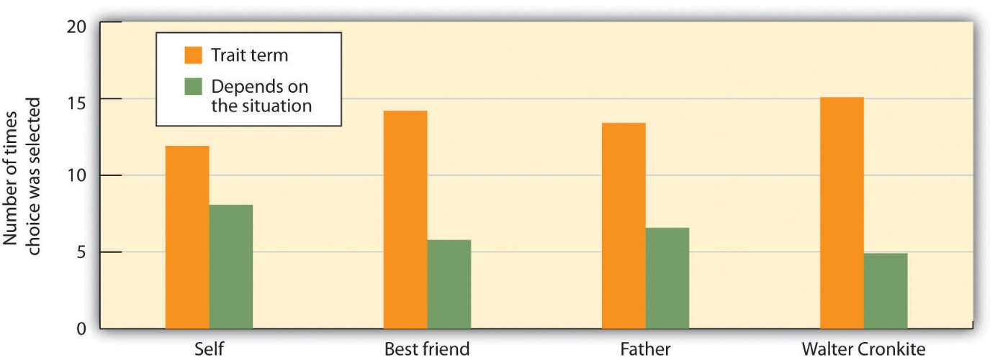
Figure 1 We Tend to Overestimate the Traits of Others. Researchers found that participants checked off a trait term (such as “energetic” or “talkative”) rather than “depends on the situation” less often when asked to describe themselves than when asked to describe others.
The human tendency to perceive traits is so strong that it is very easy to convince people that trait descriptions of themselves are accurate. Imagine that you had completed a personality test and the psychologist administering the measure gave you this description of your personality:
You have a great need for other people to like and admire you. You have a tendency to be critical of yourself. You have a great deal of unused capacity, which you have not turned to your advantage. While you have some personality weaknesses, you are generally able to compensate for them. Disciplined and self-controlled outside, you tend to be worrisome and insecure inside. At times you have serious doubts as to whether you have made the right decision or done the right thing.
I would imagine that you might find that it described you. You probably do criticize yourself at least sometimes, and you probably do sometimes worry about things. The problem is that you would most likely have found some truth in a personality description that was the opposite. Could this description fit you too?
You frequently stand up for your own opinions even if it means that others may judge you negatively. You have a tendency to find the positives in your own behaviour. You work to the fullest extent of your capabilities. You have few personality weaknesses, but some may show up under stress. You sometimes confide in others that you are concerned or worried, but inside you maintain discipline and self-control. You generally believe that you have made the right decision and done the right thing.
The Barnum effect refers to the observation that people tend to believe in descriptions of their personality that supposedly are descriptive of them but could in fact describe almost anyone. The Barnum effect helps us understand why many people believe in astrology, horoscopes, fortune-telling, palm reading, tarot card reading, and even some personality tests (Figure 2, “Horoscope and Palm Reading”). People are likely to accept descriptions of their personality if they think that they have been written for them, even though they cannot distinguish their own tarot card or horoscope readings from those of others at better than chance levels (Hines, 2003). Again, people seem to believe in traits more than they should.
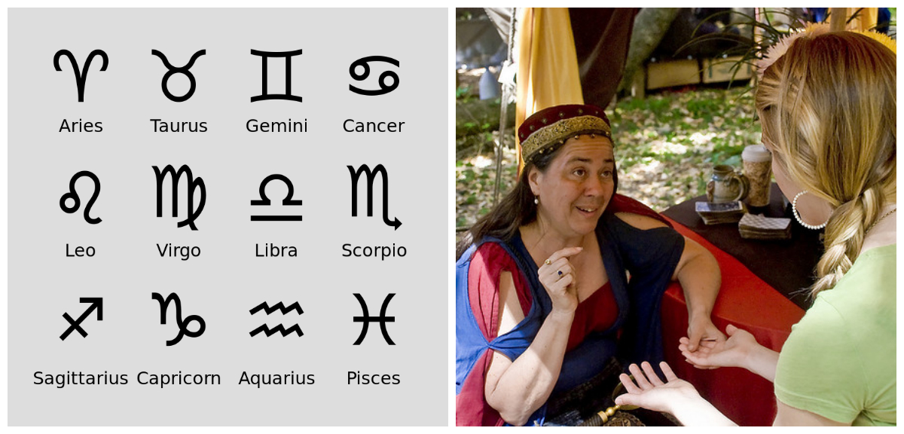

Figure 2 Horoscope and Palm Reading. The popularity of tarot card reading, crystal ball reading, horoscopes, palm reading, and other techniques shows the human propensity to believe in traits.
A second way that psychologists responded to Mischel’s 1968 findings on traits was by searching even more carefully for the existence of traits. One insight was that the relationship between a trait and a behaviour is less than perfect because people can express their traits in different ways (Mischel & Shoda, 2008). People high in extraversion, for instance, may become teachers, sales people, actors, or even criminals. Although the behaviours are very different, they nevertheless all fit with the meaning of the underlying trait.
Psychologists also found that, because people do behave differently in different situations, personality will only predict behaviour when the behaviours are aggregated or averaged across different situations. We might not be able to use the personality trait of openness to experience to determine what Paul will do on Friday night, but we can use it to predict what he will do over the next year in a variety of situations. When many measurements of behaviour are combined, there is much clearer evidence for the stability of traits and for the effects of traits on behaviour (Roberts & DelVecchio, 2000; Srivastava, John, Gosling, & Potter, 2003).
Taken together, these findings make a very important point about personality, which is that it not only comes from inside us but is also shaped by the situations that we are exposed to. Personality is derived from our interactions with and observations of others, from our interpretations of those interactions and observations, and from our choices of which social situations we prefer to enter or avoid (Bandura, 1986). In fact, behaviourists such as B. F. Skinner explain personality entirely in terms of the environmental influences that the person has experienced. Because we are profoundly influenced by the situations that we are exposed to, our behaviour does change from situation to situation, making personality less stable than we might expect. And yet personality does matter — we can, in many cases, use personality measures to predict behaviour across situations.

Is Personality More Nature or More Nurture? Behavioural and Molecular Genetics
One question that is exceedingly important for the study of personality concerns the extent to which it is the result of nature or nurture. If nature is more important, then our personalities will form early in our lives and will be difficult to change later. If nurture is more important, however, then our experiences are likely to be particularly important, and we may be able to flexibly alter our personalities over time.
In the nucleus of each cell in your body are 23 pairs of chromosomes. One of each pair comes from your father, and the other comes from your mother. The chromosomes are made up of strands of the molecule DNA (deoxyribonucleic acid), and the DNA is grouped into segments known as genes. A gene is the basic biological unit that transmits characteristics from one generation to the next. Human cells have about 25,000 genes.
The genes of different members of the same species are almost identical. The DNA in your genes, for instance, is about 99.9% the same as the DNA in my genes and in the DNA of every other human being. These common genetic structures lead members of the same species to be born with a variety of behaviours that come naturally to them and that define the characteristics of the species. These abilities and characteristics are known as instincts — complex inborn patterns of behaviours that help ensure survival and reproduction (Tinbergen, 1951). Different animals have different instincts. Birds naturally build nests, dogs are naturally loyal to their human caretakers, and humans instinctively learn to walk and to speak and understand language.
But the strength of different traits and behaviours also varies within species. Rabbits are naturally fearful, but some are more fearful than others; some dogs are more loyal than others to their caretakers; and some humans learn to speak and write better than others do. These differences are determined in part by the small amount (in humans, the 0.1%) of the differences in genes among the members of the species.
Personality is not determined by any single gene, but rather by the actions of many genes working together. There is no “IQ gene” that determines intelligence and there is no “good marriage-partner gene” that makes a person a particularly good marriage bet. Furthermore, even working together, genes are not so powerful that they can control or create our personality. Some genes tend to increase a given characteristic and others work to decrease that same characteristic — the complex relationship among the various genes, as well as a variety of random factors, produces the final outcome. Furthermore, genetic factors always work with environmental factors to create personality. Having a given pattern of genes doesn’t necessarily mean that a particular trait will develop, because some traits might occur only in some environments. For example, a person may have a genetic variant that is known to increase his or her risk for developing emphysema from smoking. But if that person never smokes, then emphysema most likely will not develop.

Studying Personality Using Behavioural Genetics
Perhaps the most direct way to study the role of genetics in personality is to selectively breed animals for the trait of interest. In this approach the scientist chooses the animals that most strongly express the personality characteristics of interest and breeds these animals with each other. If the selective breeding creates offspring with even stronger traits, then we can assume that the trait has genetic origins. In this manner, scientists have studied the role of genetics in how worms respond to stimuli, how fish develop courtship rituals, how rats differ in play, and how pigs differ in their responses to stress.
Although selective breeding studies can be informative, they are clearly not useful for studying humans. For this psychologists rely on behavioural genetics — a variety of research techniques that scientists use to learn about the genetic and environmental influences on human behaviour by comparing the traits of biologically and nonbiologically related family members (Baker, 2004). Behavioural genetics is based on the results of family studies, twin studies, and adoptive studies.
A family study starts with one person who has a trait of interest — for instance, a developmental disorder such as autism — and examines the individual’s family tree to determine the extent to which other members of the family also have the trait. The presence of the trait in first-degree relatives (parents, siblings, and children) is compared with the prevalence of the trait in second-degree relatives (aunts, uncles, grandchildren, grandparents, and nephews or nieces) and in more distant family members. The scientists then analyze the patterns of the trait in the family members to see the extent to which it is shared by closer and more distant relatives.
Although family studies can reveal whether a trait runs in a family, it cannot explain why. In a twin study, researchers study the personality characteristics of twins. Twin studies rely on the fact that identical (or monozygotic) twins have essentially the same set of genes, while fraternal (or dizygotic) twins have, on average, a half-identical set. The idea is that if the twins are raised in the same household, then the twins will be influenced by their environments to an equal degree, and this influence will be pretty much equal for identical and fraternal twins. In other words, if environmental factors are the same, then the only factor that can make identical twins more similar than fraternal twins is their greater genetic similarity. Twin studies divide the influence of nature and nurture into three parts:
- Heritability (i.e., genetic influence) is indicated when the correlation coefficient for identical twins exceeds that for fraternal twins, indicating that shared DNA is an important determinant of personality.
- Shared environment determinants are indicated when the correlation coefficients for identical and fraternal twins are greater than zero and also very similar. These correlations indicate that both twins are having experiences in the family that make them alike.
- Nonshared environment is indicated when identical twins do not have similar traits. These influences refer to experiences that are not accounted for either by heritability or by shared environmental factors. Nonshared environmental factors are the experiences that make individuals within the same family less alike. If a parent treats one child more affectionately than another, and as a consequence this child ends up with higher self-esteem, the parenting in this case is a nonshared environmental factor.
In the typical twin study, all three sources of influence are operating simultaneously, and it is possible to determine the relative importance of each type.
An adoption study compares biologically related people, including twins, who have been reared either separately or apart. Evidence for genetic influence on a trait is found when children who have been adopted show traits that are more similar to those of their biological parents than to those of their adoptive parents. Evidence for environmental influence is found when the adoptee is more like his or her adoptive parents than the biological parents.
The Big Five trait dimensions have a heritability of 40% to 50%. Overall, there is more influence of nature than of parents. Identical twins, even when they are raised in separate households by different parents (column 4), turn out to be quite similar in personality, and are more similar than fraternal twins who are raised in separate households (column 5). These results show that genetics has a strong influence on personality. The environment also plays an important role in personality (Turkheimer & Waldron, 2000). For instance, for sexual orientation the estimates of heritability vary from 18% to 39% of the total across studies, suggesting that 61% to 82% of the total influence is due to environment.
You might at first think that parents would have a strong influence on the personalities of their children, but this would be incorrect. Research finds that the influence of shared environment (i.e., the effects of parents or other caretakers) plays little or no role in adult personality (Harris, 2006). Shared environment does influence the personality and behaviour of young children, but this influence decreases rapidly as the child grows older. By the time we reach adulthood, the impact of shared environment on our personalities is weak at best (Roberts & DelVecchio, 2000). What this means is that although parents must provide a nourishing and stimulating environment for children, no matter how hard they try they are not likely to be able to turn their children into geniuses or into professional athletes, nor will they be able to turn them into criminals.
References:
https://opentextbc.ca/introductiontopsychology/chapter/11-1-personality-and-behavior-approaches-and-measurement/

